- Go to livebuilds backoffice
- Make a purchase order for a product with decimals unit of meassuere, for example Sirloin wich has Kilograms. Indicate an entire quantity
- Book it and press receipt
- Go to frontend AWO and open the PO
- Try to indicate a big amount with decimals in the received quantity. Indicate a big number
- Realize that if the number does not fit in the box, the decimals are not considered.

Picture 1: the number fits in the box, so it is added well
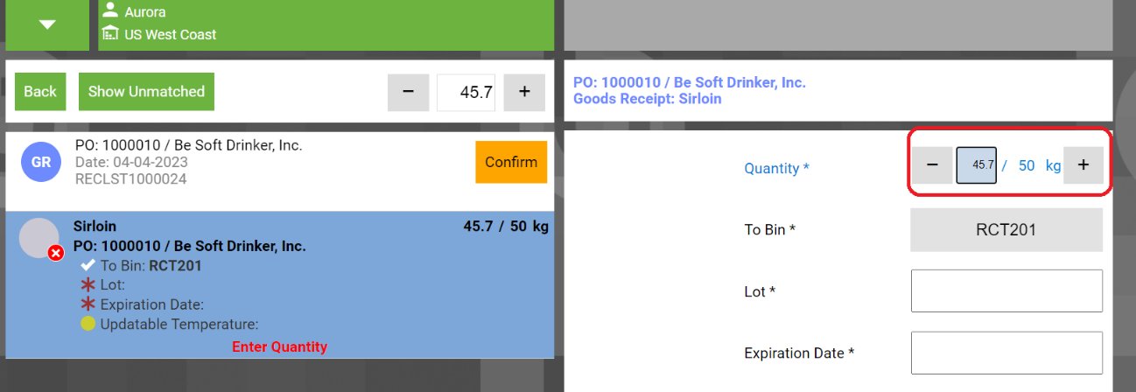
Picture 2: If the number introduced is bigger than the space available, it jumps to another space or makes extrange things without adding the decimal part.
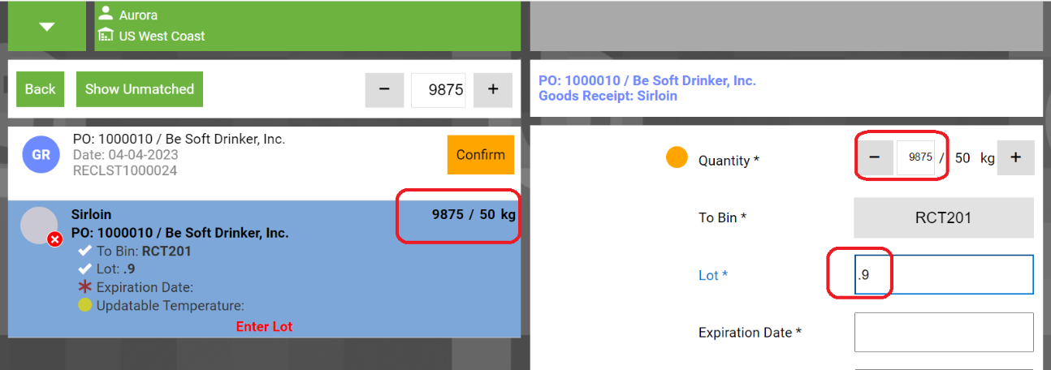

SUGGESTION TO FIX IT: Add the same pop up as in COUNTS in order to allow to introduce the amount in a good way:
